4. Analysis Conclusions
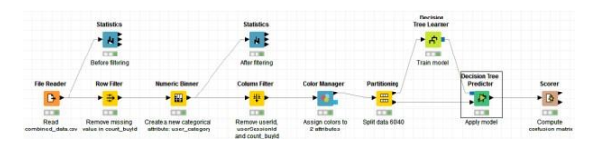
The final KNIME workflow is shown below:

According to the resulting decision tree, it obviously shows that the predicted user_category is different in various platforms, the users on the platform android, linux, windows and mac are almost PennyPincher, however, most users which on the platform iphone are HighRoller.
